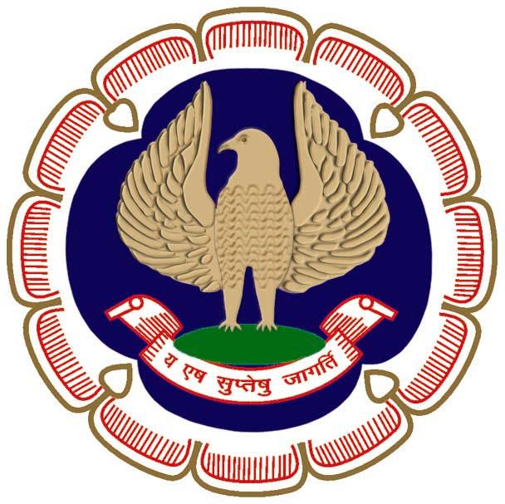
12 CPE Hours

Two Days National Workshop
Organized By Professional Development Committee, ICAI
Hosted By Madurai Branches of SIRC of ICAI
Date | 02nd and 03rd June 2023 |  | Venue |  |  | ICAI Bhawan, Madurai
Day 1: 02-06-2023 Friday
PROGRAMME
Time |  | Topic |  |  | Speaker
09:00 am – 09:30 am |  | Registration
09:30 am – 10:30 am |  | Inauguration  Dr Palanivel Thiaga Rajan  Minister for Information Technology and Digital Services of Tamil Nadu
10:30 am – 12:00 pm |  | Code of Ethics |  |  | CA. Prasanna Kumar, CCM,  Visakhapatnam
12:15 pm – 01:45 pm |  | Sec. 56– An evolving deeming fiction |  |  | CA. Piyush Chhajed, CCM, Mumbai
02:30 pm – 04:00 pm |  | Audit Trail & 2) Key Considerations for Statutory Audits |  |  | CS. Gourav Kumar K, Chennai
04:15 pm – 05:45 pm |  | Recent Judgments in GST |  |  | CA. SS Gupta, Mumbai
Day 2: 03-06-2023 Saturday
PROGRAMME
Time |  | Topic |  |  | Speaker
10:00 am – 11:30 am |  | Optimising All tools in CA profession |  |  | CA Narasimhan E, Bangalore
11:45 am – 01:15 pm |  | Emerging Opportunities in Wealth Management |  |  | Shri. Satyanarayan Yanmantram, Chennai
02:00 pm – 03:30 pm |  | Issues in Capital Gains |  |  | CA. Krishnan S, Chennai
03:45 pm – 05:45 pm |  | Panel Discussion on issues in Income Tax |  |  | CA. P V Rajarajeswaran, Madurai
Programme Director  CA. Rajendra Kumar P, Central Council Member, ICAI |  |  |  | Programme Convenor:  CA R Hanumandhan  Chairman, Madurai Branch of SIRC of ICAI  Madurai Branch of SIRC of ICAI  "ICAI Bhawan",  4/1. Old Natham Road, Opp. Balamandiram School,  Visalakshipuram, Madurai - 625 014.  Ph: 0452 - 2640968/4220968/82201 11968  Email: madurai@icai.org / Web:www.madurai-icai.org
Fees Details & Registration Link: https://events.madurai-icai.org/

Bank Details for NEFT/RTGS: Account Name: MBSIRC OF ICAI
Saving Account No: 134001000005741
IFSC Code: IOBA0001340
Name of Bank Indian Overseas Bank,
Visalakshipuram Branch , Madurai 625 014
Contact:
Additional Director & Secretary, Professional Development Committee
The Institute of Chartered Accountants of India
(Set up by an Act of Parliament)
Phone: +91-11-30110547 (Direct)

Limited Seats, registration will be on first come-first serve basis.

